New Changing Pavillion

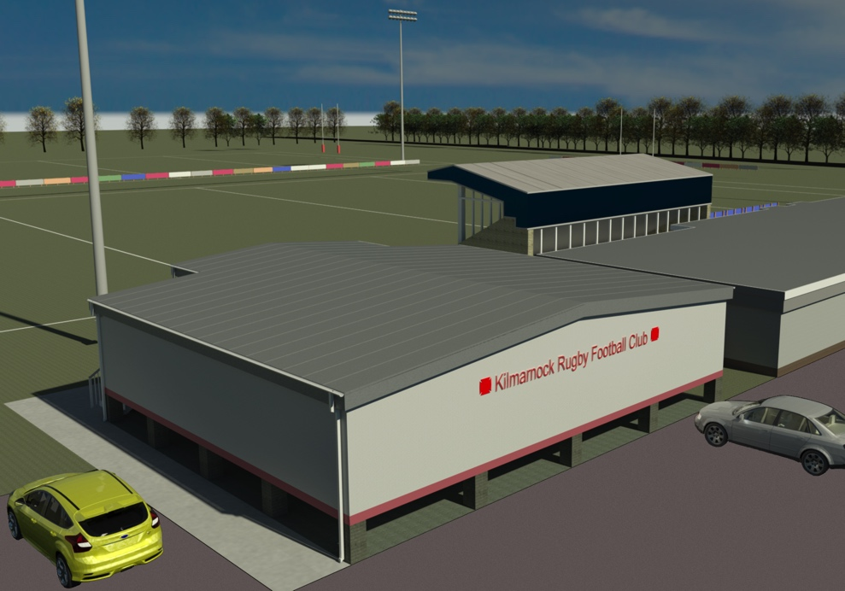

New Changing Rooms

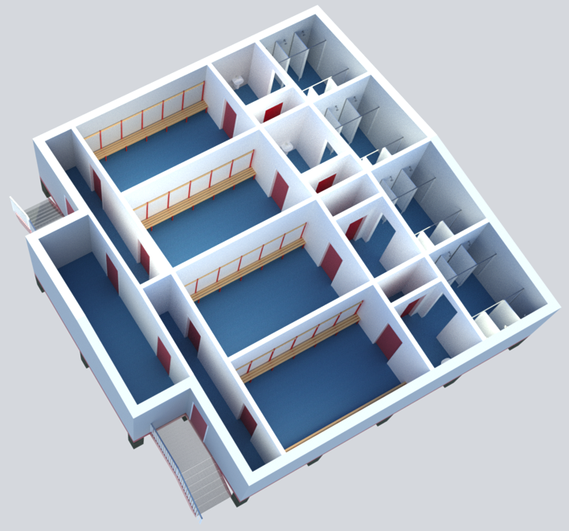

YOU CAN HELP

BUILD & SECURE

YOUR CLUB’S

FUTURE AT BELLSLAND

Macintosh HD:Users:theguthries:Documents:KRFC:KRFC150years.pdf

Kilmarnock Rugby Football Club

Dear Club Members, Sponsors, Supporters & Friends,

It is now almost 50 years since the facilities at Bellsland were originally opened and Kilmarnock RFC finally had a home of our own. These facilities were the envy of many clubs back in the day –but they are in desperate need of upgrading as we head into our next 150 years.

Kilmarnock RFC has a tremendous reputation for encouraging youngsters and ladies to come to Bellsland for coaching and training in increasing numbers. Bellsland was the birthplace of Trust Rugby International, which has now grown to include ‘Clan’ teams throughout the world. However, our changing facilities are no longer suitable to accommodate all these diverse groups and, indeed, fall short of the preferred standard requested by both Sport Scotland and the SRU.

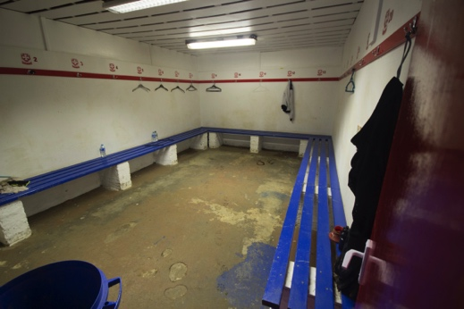 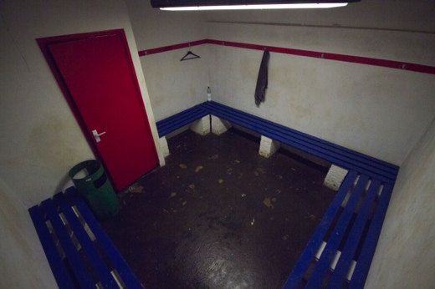

A great deal of hard work has been going on in the background to plan, cost and fund four new changing rooms. We are delighted to tell you that significant grant funding has been secured from the SRU, Sport Scotland and East Ayrshire Council. However, the club needs to make our own financial contribution to the overall cost of the project to trigger the release of these funds.

This is where we would like you to help out. Many have enjoyed great times at Bellsland regardless of our playing abilities and whether we learned the game there or joined later in our rugby careers as a player, social member, spectator or with a visiting team. We have made great friendships and bonds. Most importantly – we have wonderful memories of the place. As we celebrate 150 years in 2018 we want to build the foundations for such memories for future generations. As we saw 50 years ago – improved facilities not only attract talented players at all levels, but help retain them and see the club move forward.

**See the back page of what the clubhouse will look likeWAYS TO DONATE**

We are launching fund raising options to ensure we raise the required amount, £40,000 to make this project a reality – and we need to move quickly to satisfy the terms of the grants we have been awarded, otherwise the grant funding will be removed from the club.

**£150 for 150**

As it is our 150th anniversary we are asking that individuals donate £150 to the project. Our immediate target is for 150 people to donate, this would give us £22,500. You will be able to donate in a lump sum or in monthly installments.

£150 Donors will have their name – or the name of anyone they propose – displayed on a history board within the new facility. You will also have the reward of knowing that your generosity has helped the next generation of budding sports people have benefited from your gesture and that KRFC can begin the journey back towards the top end of Scottish club rugby.

**BUSINESS DONATIONS FOR CHANGING ROOM**

We are also offering businesses and/or individuals the opportunity to donate £5,000 per dressing room in return for having the room named after them in recognition of their generosity. There will be 4 new dressing rooms. This will help us raise a further £20,000 towards our goal.

**OTHER DONATIONS**

We appreciate that not everyone can donate the amounts suggested above. However, individuals and businesses who are interested in contributing in some way are welcome to donate what they can.

If you wish to donate please fill out the form enclosed with this letter and return it with cheque to the club ASAP. Please bear in mind that if you tick the Gift Aid the club will receive a further 25p for every pound donated helping us achieve our goal that little bit quicker.

If you have any questions please contact kilmarnockrfc@hotmail.com .

We believe that KRFC can head back towards the top of Scottish club rugby. We have a proud past and can have a promising future. Any support you can give is most welcome and greatly appreciated. We look forward to hearing from you – and seeing you at Bellsland soon!

Kind Regards,



President Kilmarnock RFC